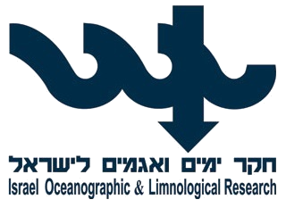
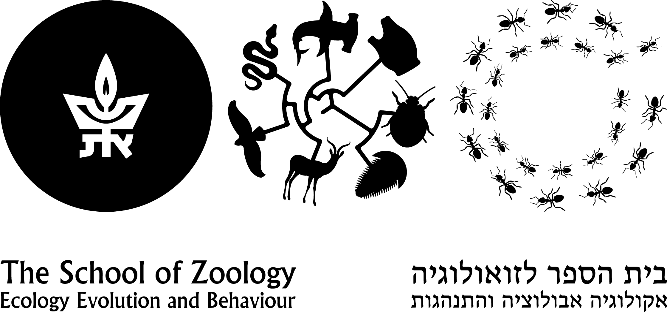
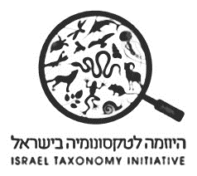
BIOLOGY, IDENTIFICATION AND SYSTEMATICS OF CHAETOGNATHA
7-8, 10-12 April, 2019, Tel-Aviv University
Lecturer: Dr. Annelies C. Pierrot-Bults (APB)
Address: Institute for Biodiversity and Ecosystem Dynamics (IBED)
University of Amsterdam
The Netherlands
Email: pierrot@uva.nl
Website: science.uva.nl/ZMA/Invertebrates/Invertebrates/pierrot.html
Course organizer and instructor: Dr. Tamar Guy-Haim (TGH)
Address: National Institute of Oceanography, Haifa
Israel Oceanographic and Limnological Research (IOLR)
Email: tamar.guy-haim@ocean.org.il

Course host: Prof. Jonathan Belmaker
Address: School of Zoology and The George S. Wise Faculty of Life Sciences
Tel Aviv University
Email: jbelmaker@post.tau.ac.il

Course hours: Lecture hours= 16; Lab hours= 20; Field work hours= 8

The course is offered for 14 participants and taught in English.

COURSE DESCRIPTION

Chaetognatha (arrow worms) is a phylum of abundant and ubiquitous marine predators, comprising 20 genera and approximately 150 species. Using their grasping hooks, the transparent-body chaetognaths are voracious consumers of other planktonic organisms, including copepods and fish larvae, and are preyed upon planktivorous fish, thus play an important role in marine foodwebs. The classification of this phylum has long puzzled taxonomists, and recent molecular research have placed it in within Protostomia, although presenting deuterostome-like features.
Twenty-one species of Chaetognatha are known in the Mediterranean Sea, only two of which are of Indo-Pacific origin. Chaetognaths are considered as excellent bioindicators of water masses, explaining the large dissimilarity of species composition between the Mediterranean and the Red Sea, markedly higher than other zooplankton groups. Monitoring changes in chaetognaths’ species composition in the Eastern Mediterranean Sea may thus serve as an important tool in identifying climatic induced changes in the regional hydrography.
This course will provide students with an understanding of the biology and evolution of chaetognaths, and the identification of species of the Mediterranean and Red Sea. The students will experience hands-on field and lab techniques of sampling, sample processing, and using keys for identification.

SHORT COURSE OUTLINE

Day | Topics | Activities
1 | Welcome and intro to Chaetognatha (TGH, APB) | Frontal lessons.
2 | Chaetognatha biology and morphology (APB) | Frontal lessons and lab. Using identification keys.
3 | Chaetognatha sampling and preservation methods (TGH) | Cruise: sampling in the Mediterranean Sea (R/V Mediterranean Explorer).
4 | Chaetognatha diversity (APB) | Lab: sorting and identifying specimens.
5 | Chaetognatha diversity (APB)  Exam | Lab: sorting and identifying specimens.

DETAILED PROGRAM

Day 1 – April 7 2019 (Sunday)
- 9:00 – Welcome and course introduction
- Diversity and Biogeography of Chaetognaths
- Role of Chaetognaths in the food chain
Day 2 – April 8 2019 (Monday)
- Morphology and Taxonomy of Chaetognatha, introduction to genera and species
- How to process samples, taxonomic and/or ecological, and procedures for storage and conservation of plankton samples
- Hands on identification of preserved specimens
- Using different identification tools
Day 3 – April 10 2019 (Wednesday)
- 7:30 – 11:30 Group #1 MedEx cruise, Herzliya
- 11:30 – 15:30 Group #2 MedEx cruise, Herzliya
- Collecting near-shore and offshore samples of different depth layers
- Biomass assessments
- Fixation and preservation techniques
Day 4 – April 11 2019 (Thursday)
- Identification of samples
- Diversity of near-shore and offshore samples
Day 5 – April 12 2019 (Friday)
- identifying specimens
- writing up results
- Practical exam

COURSE BIBLIOGRAPHY
- Pierrot-Bults, A.C. Chaetognatha. In: Marine Plankton: A Practical Guide to Ecology, Methodology, and Taxonomy. Castellani, C. and Edwards, M. eds., 2017. Oxford University Press.
- Bone, Q., Kapp, H. and Pierrot-Bults, A.C., 1991. Biology of chaetognaths. Oxford University Press.
- Pierrot-Bults, A.C. and Nair, V.R., 1991. Distribution patterns in Chaetognatha. In: Bone, Q. Oxford University Press.
- Ball, E.E. and Miller, D.J., 2006. Phylogeny: the continuing classificatory conundrum of chaetognaths. Current Biology, 16(15), pp.R593-R596.
- Jennings, R.M., Bucklin, A. and Pierrot-Bults, A., 2010. Barcoding of arrow worms (Phylum Chaetognatha) from three oceans: genetic diversity and evolution within an enigmatic phylum. PLoS One, 5(4), p.e9949.
- Terbiyik, T., Cevik, C., Toklu-Alicli, B. and Sarihan, E., 2007. First record of Ferosagitta galerita (Dallot, 1971) [Chaetognatha] in the Mediterranean Sea. Journal of plankton research, 29(8), pp.721-726.
- Furnestin, M.L., 1953. Sur quelques chaetognathes d'Israel. Sea Fisheries Research Station, Division of Fisheries, Ministry of Agriculture, State of Israel.
- Casanova, J.-P., 1985. Le chaetognathes de la Mer Rouge: remarques morphologiques et biogéographique, description de Sagitta erythraea sp. n. Rapport et Procès-verbeaux de la Commission por l'exploration scientifique de la Mer Méditerranée 29, pp269-274.s
- Pierrot-Bults website species-identification of the world Chaetognath species of the world

Course Registration Form

Please send the filled form to tamar.guy-haim@ocean.org.il until 10 March 2019.

First name: |  | Last name:
Id:
Address:
Phone: |  | e-mail:
Academic Background: |  | Degree. |  | Status. | Year.
University / College:
Current position:
Workplace:
Relevant background for the course:
Reasons for application:

